2.3 Problem 3

Load the iris sample dataset into Python using a Pandas dataframe. Perform a PCA using the Scikit Decomposition component, and provide the percentage of variance explained by the 1st Principal Component. Use Matplotlib to plot the 1st/2nd Principal Components to recreate the scatterplot shown in class, with colored classes for each flower type.

**Answer:**

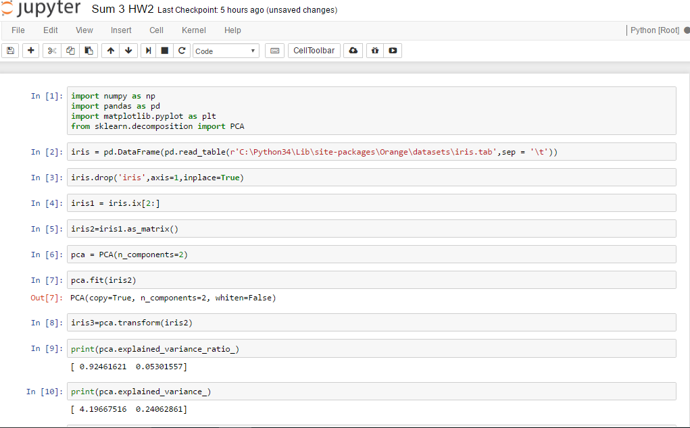

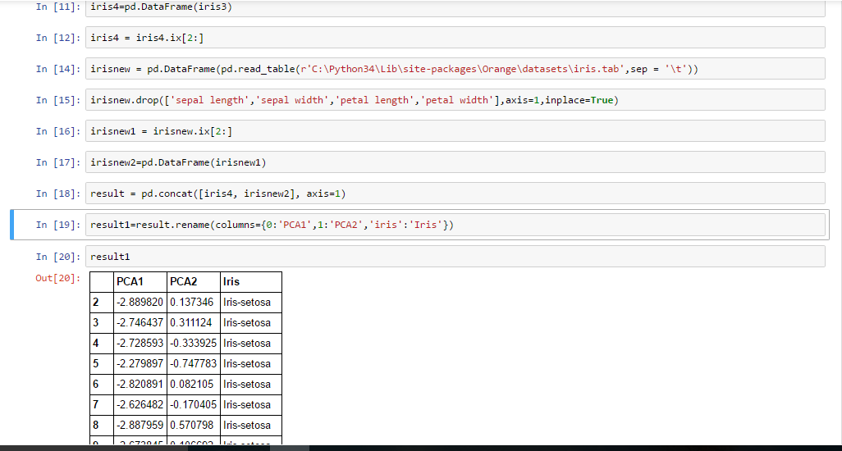

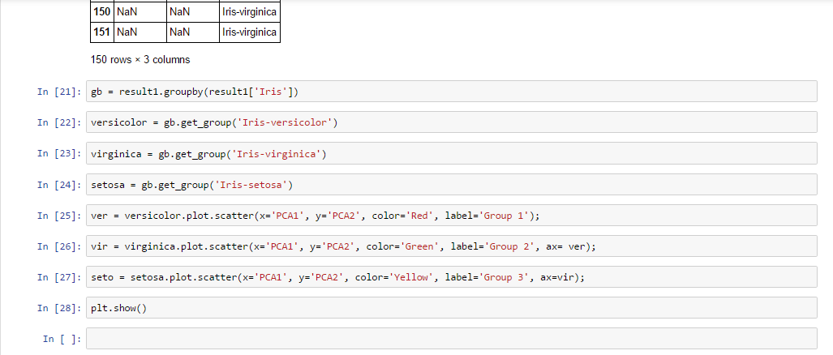

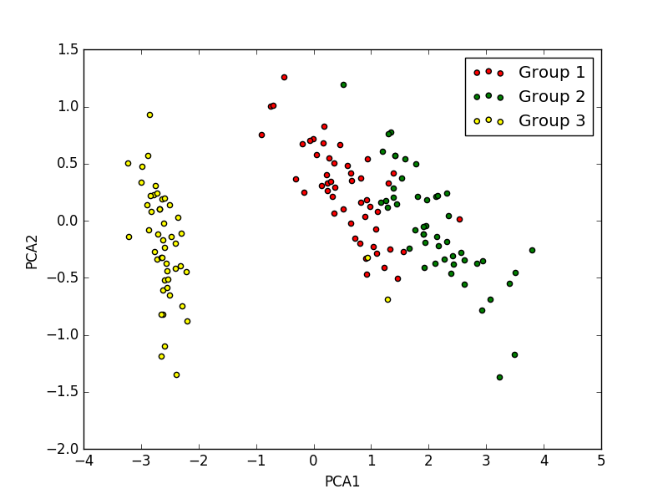

Here, Variance as per the first PCA is 92.4%